Gueco, Greiden F.
BSIS-I102
PC1

Task 1: Query Statement
create database Company;
use company;
create table employees_tbl
(Employee_id int(20) unique auto_increment primary key,
Employee_Name varchar(255) not null,
Manager_id int(20));

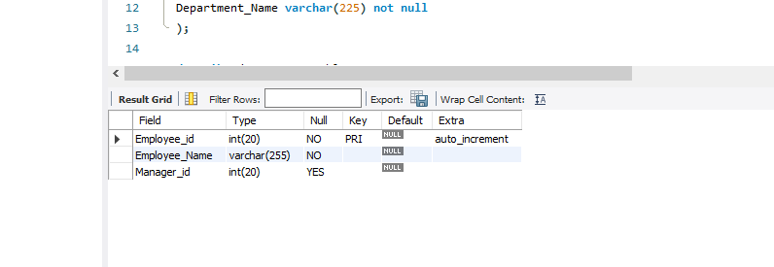
describe employees_tbl;

create table departments_tbl
(Department_id int(20) unique auto_increment primary key,
Department_Name varchar(225) not null
);

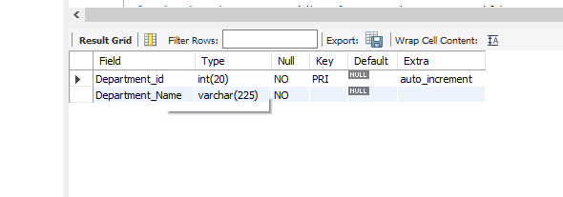
describe departments_tbl;

create table employee_departments
(Employee_id int(11),
foreign key (Employee_id) references employees_tbl(Employee_id),
Department_id int(11),
foreign key (Department_id) references departments_tbl(Department_id)
);

describe employee_departments;
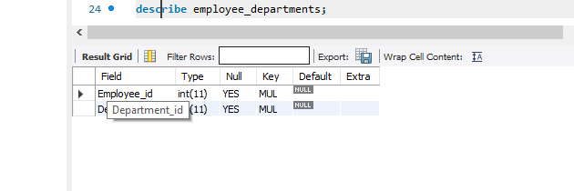
create table employee_projects
(employee_id int,
project_name varchar(225) not null,
foreign key (employee_id) references employees_tbl(employee_id));

describe employee_projects;
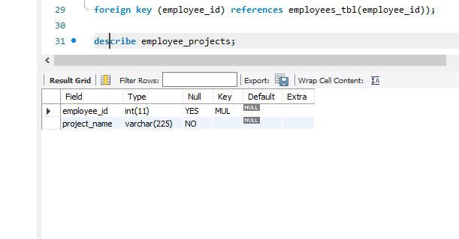
create table managers_tbl
(manager_id int unique auto_increment primary key,
employee_id int,
foreign key(employee_id) references employees_tbl(employee_id));

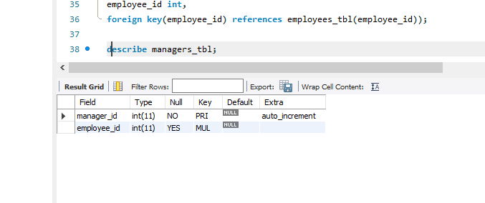
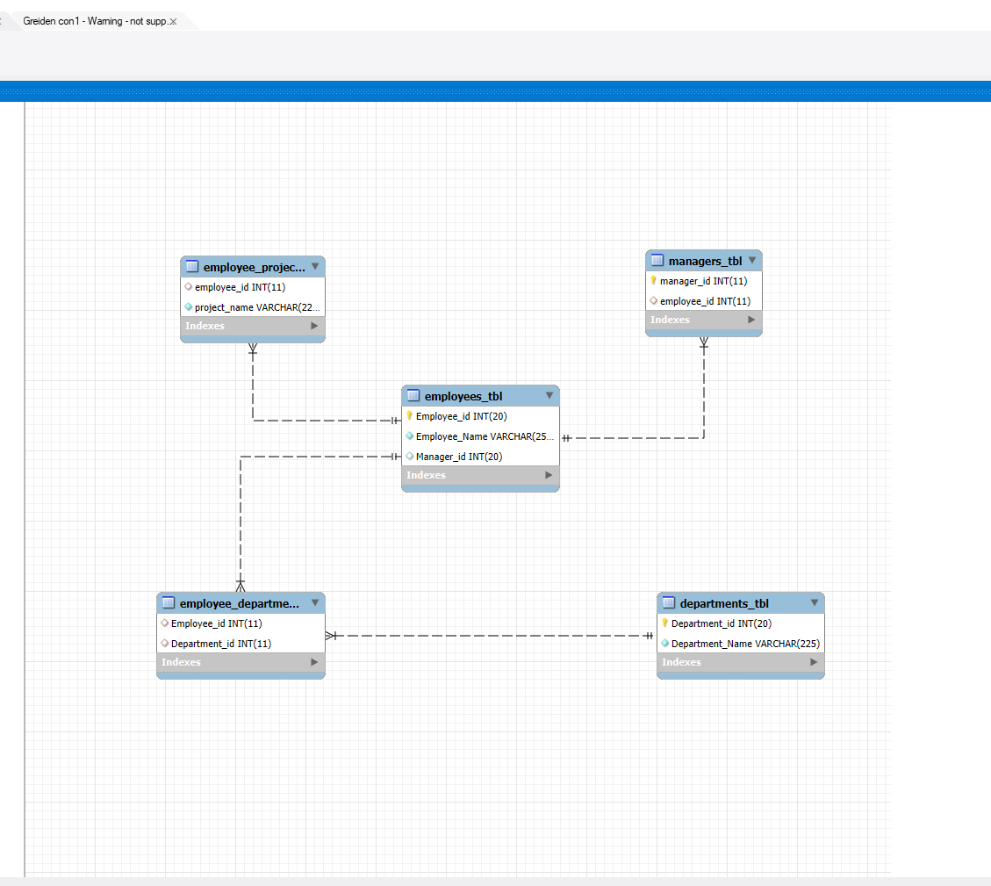
describe managers_tbl;pp

